- Basic Programming Techniques in C#

- Compiling and Running the application
- Compile:
Click on “Build” menu – “Build Solution”. (or) Press Ctrl+Shift+B.
- Run:
Click on “Debug” menu – “Start Debugging”. (or) Press F5.

- Keywords
You can observe the available keywords in C#.
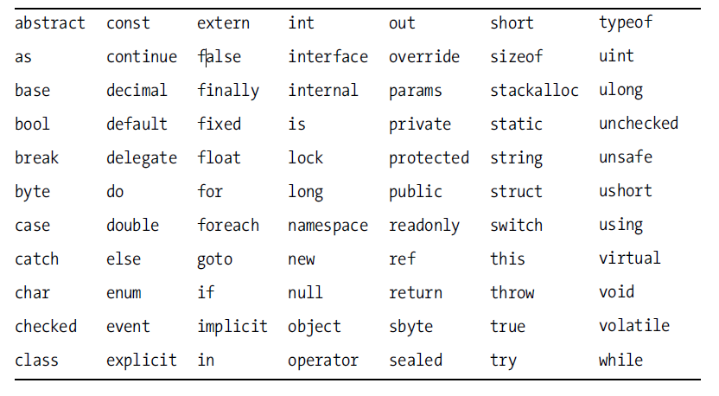
- Writing output
- Write():
Syn 1: System.Console.Write(“any string here”);
Syn 2: System.Console.Write(variable);
The Syntax 1 displays the given string on the console output.
The syntax 2 displays the value of the given variable on the console output.

Note: Here, “System” is the namespace; “Console” is the class; and the “Write” is the method.

- WriteLine():
Syn 1: System.Console.WriteLine(“any string here”);
Syn 2: System.Console.WriteLine(variable);

The Syntax 1 and 2 works same as “Write()” method, but moves the cursor automatically to the next line after printing the output on the console window..

Examples:
- System.Console.WriteLine(“Welcome”);
- System.Console.Write(“C# Programming..”);
- System.Console.WriteLine(“Current date and time is “ + DateTime.Now);

- Reading input
- ReadLine():
Syn: variable = System.Console.ReadLine();

The input value entered in the console window, will be assigned to the variable.
Note: This method always the returns the entered value in “string” mode.

- Read():
Syn: System.Console.Read();

This statement makes the cursor to wait for pressing “Enter” key on the keyboard. This statement doesn’t takes in input value.

- Comments
- Single Line Comment:
//comment

- Multi Line Comment:
/* comment line 1
comment line 2
comment line 3
*/

- Skip writing the imported namespaces
- When you import any namespace, all of the classes of that namespace are implicitly accessible in the code.
- For example, when we import “System” namespace, all of the classes under “System” namespace can be accessed without specifying “System.”.
- Ex:
When you import like:
using System;
To access “Console” class:
System.Console is not required. Console is enough.
Application 2: Demo on Reading Input and Comments
using System;
using System.Collections.Generic;
using System.Linq;
using System.Text;

/*An application, that reads your name
and age and displays them.*/
namespace InputAndComments
{
class Program
{
static void Main(string[] args)
{
//declare variables
string name;
int age;
//read name of the person
Console.WriteLine("Enter your name:");
name = Console.ReadLine();
//read age
Console.WriteLine("Enter your age:");
age = Convert.ToInt32(Console.ReadLine());
Console.WriteLine(name + " is about " + age + " years old.");
Console.Read();
}
}
}

